**Shock Index 15 min After Delivery as a Predictor of Total Blood Loss**

**Introduction**

This analysis will address the possible correlation between a woman’s shock index 15 minutes after delivery and the total amount of blood lost during labor.

**Dataset and Methods**

This analysis uses data from a study focusing on the effects of administering oxytocin to prevent blood loss during the third stage of labor. This pph dataset has 39 variables that include information about the mother and her delivery. The variables of interest in this analysis are the mother’s heart rate 15 minutes after delivery, her systolic blood pressure 15 minutes after delivery, and her total amount of blood lost during the third stage of labor in milliliters. The potentially predictive variable shock index was calculated by dividing the systolic blood pressure variable by the mother’s heart rate. Given that the variables of interest are all numerical in nature, a regression analysis is most appropriate. First, the data will be plotted and a regression analysis will begin. Assumptions required will be checked and transformations will be performed if necessary. Influential outliers, if any, will be identified. Lastly, a regression inference will be performed.

**Exploratory Data Analysis**

This analysis began with the creation of a plot with a regression line comparing the mother’s shock index 15 minutes after delivery and her log transformed total blood loss. A red regression line was also added. The data points do not initially show a clear trend, but the regression line shows a shallow downwards angle (fig 1). This regression line has a slope of -6.325, which is both negative and shallow, which matches the visual representation of the line.

**Results**

There are a number of intermediate steps prior to determining if shock index is a predictor of total blood loss. The first step is creating a linear model, which was explored in the previous section. Figure 1 shows a log transformed y-axis, which is explained in this section. Influential outliers were found using Cook's distance; there were none found. Next, assumptions required for regression inference must be checked. A residual pilot can help determine the linearity and equal variance of the data, which are both assumptions. Figure 2 shows that the data’s relationship is not very linear and displays a cone shape emblematic of unequal variance (fig 2). When the total blood lost variable is log transformed and the plot is remade, a linear relationship with equal variance is achieved (fig 3). The assumption of normality must also be met, which is confirmed by the shape of figure 4. The final assumption is that the values are independent of each other, which is confirmed by the study design. Summary statistics for the model were then generated. A null hypothesis of shock index not being a predictor of total blood loss was formed alongside an alternate hypothesis of it being a predictor. A p-value of $5.51×{10}^{-7}$ was found. The $R^{2}$ for this relationship was determined to be 0.05.

**Conclusion**

This analysis found that there is significant evidence that a woman’s shock index 15 minutes after delivery is a predictor of the total amount of blood lost during labor. The p-value was significant as it was below a value of 0.05, meaning that the alternative hypothesis of shock index being a predictive value for total blood loss is true. The coefficient of determination (written as $R^{2}$) is then used to determine how much of the variability in blood loss can be explained by the shock index. For this model, the $R^{2}$ is 0.05, meaning only 0.05% of the variance in the total blood loss of mothers can be explained by the model created. The amount of total blood lost can be predicted by using the model $\hat{y}=6.4511-0.6325×SI Score 15 min after birth$.

**Appendix**

Figure 1

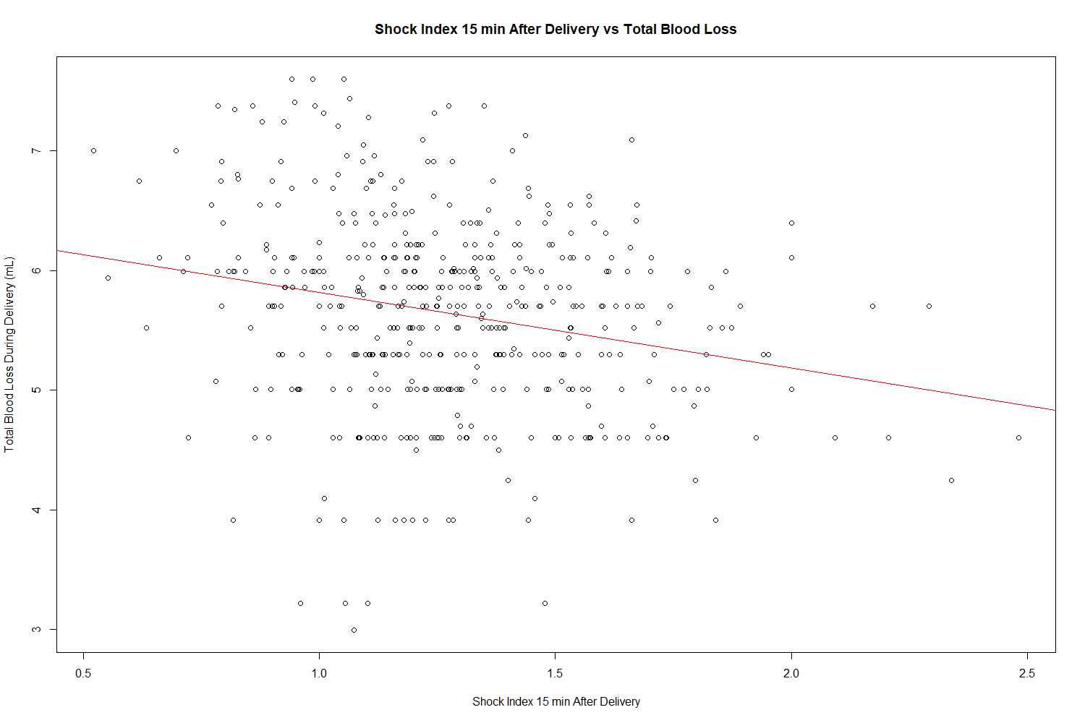

Figure 2

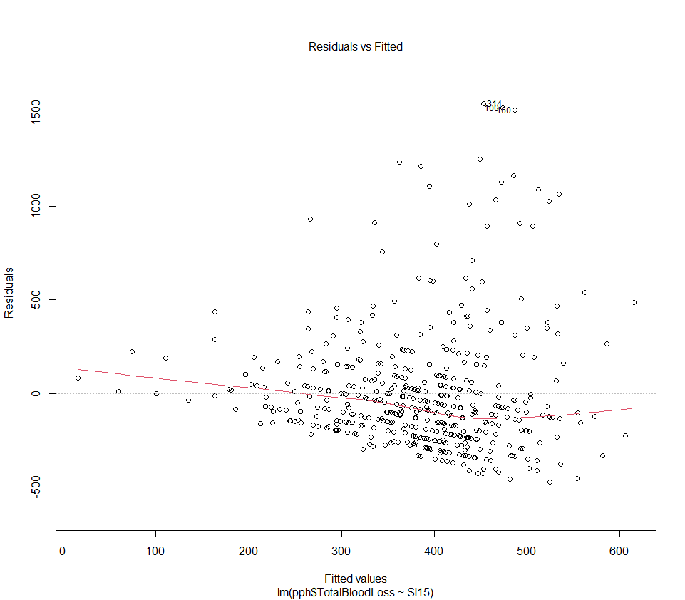

Figure 3

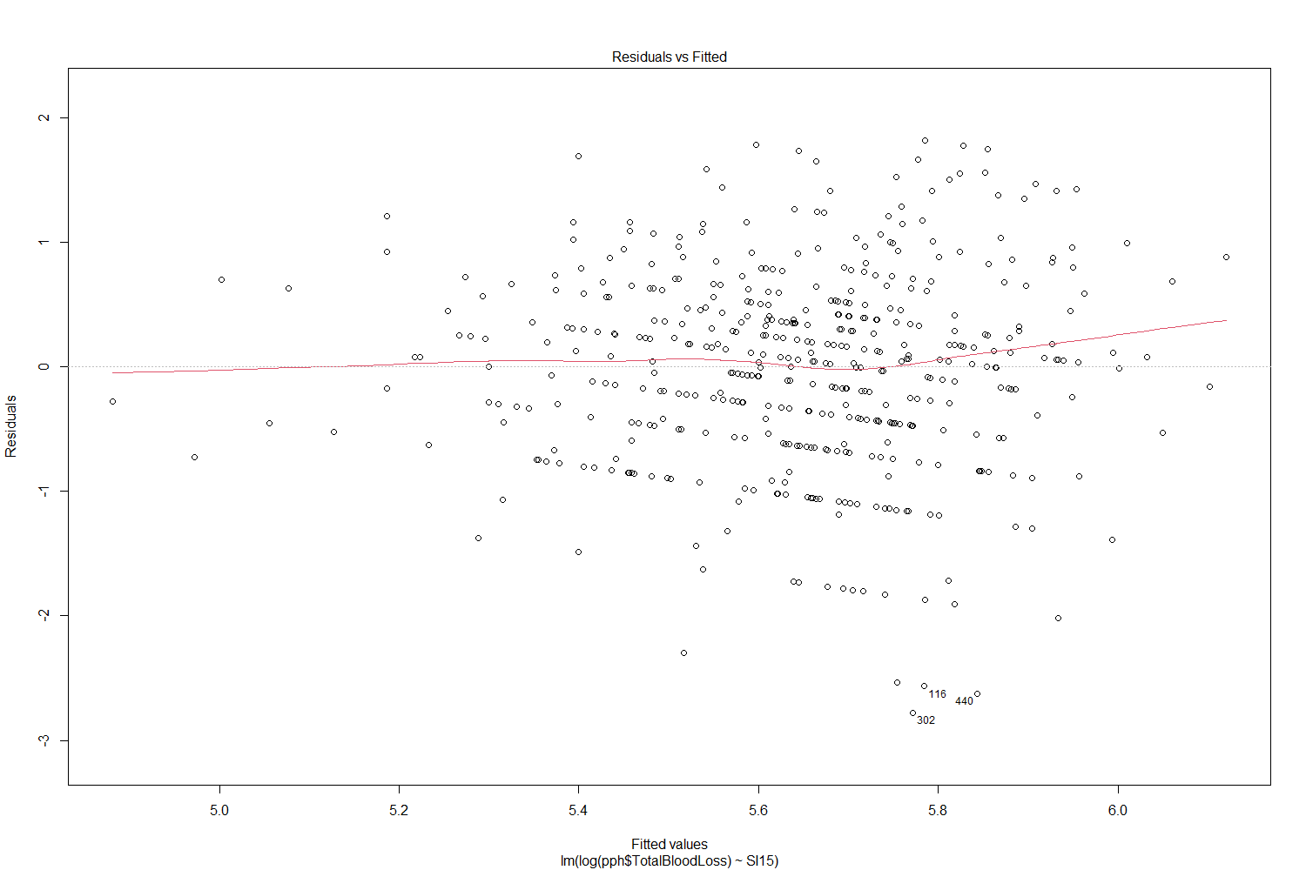

Figure 4

